DeweyDecimalApp

Readme

Programming language: C#

Made with: Visual Studio 2022

Software by Kashik Ramnath (ST10117137)

**Description**

DeweyDecimalApp is a program that uses C# Winforms. The application is responsible for teaching users on how the Dewey Decimal System works. The application currently has 2 teaching features:

1) Replacing Books:  
This is done by generating 10 Dewey decimals and displaying them to the user - then allowing the user to enter the values in the correct order (ascending); if the answer is incorrect the user will gain points, if not the user will lose points, however the answer will be showed so the user can learn from it.

2) Identifying Areas:  
This is a matching the columns mini-game in which 4 call-numbers are displayed in column A, and 7 possible answers (7 descriptions) are in column B, 3 of the 7 descriptions are incorrect, and 4 of the seven are correct. The user must use a combo-box to choose the appropriate answer from column B to match column A. Every turn the role is alternated between matching the call-numbers to the descriptions, to matching the descriptions to the call-number. The user gains 2 points for every answer that is correct and loses 1 point for every incorrect answer.

This task helped further develop my understanding on coding abilities and improved understanding of algorithms and sorting.

**Finding and opening software**

1) Open Visual Studio 2022 program.

2) Click on the option to open a new folder.

3) Navigate to the repos file on your computer.

This is commonly located as follows--> C:\Users\***yourname***\source\repos

4) Select the file called “DeweyDecimalApp”.

5) Once opened right click on the software name, DeweyDecimalApp, and choose to open/run file.

**Build project**

Once file is opened in Visual Studio 2022:

1) Click "Build" located on the top of screen menu bar.

2) Choose the "Build solution" from Build menu.

An alternative method of doing so, is holding ctrl+b on your keyboard once the file is opened in visual studio (as explained above, under "Finding and opening software").

**Running the software**

Once file is opened in Visual Studio 2022, as shown under the "Finding and opening software" heading above:

1) Click "Debug", located on the top menu bar in Visual Studio 2022.

2) Choose "Start without debugging" from the Debug menu.

Step 1: Navigate to repos folder

Step 2: Drag and drop file into repos

Step 3: Launch Visual Studio and click Open a local folder

Step 4: Choose and open the file

Step 5: On Menu Bar, build the file

Step 6: Once successful, go to DeweyDecimalApp and click green start-up button

Step 7: Click either of the 3 buttons to launch the application features, or ‘Exit App’ to close the application. In this stage only ‘Replacing Books’ feature is available; the rest is coming soon to production.

Step 8: Once ‘Replacing Books’ option is chosen the click on the combo-boxes on the right had side to enter values in ascending order.

Step 9: once your answers are chosen, click submit.

Step 10: If you are correct, you will gain 5 points and the Dewey Decimal numbers will refresh

Step 11: If you are incorrect, you will lose 5 points, the numbers will refresh, however you will be shown what the answers were

Step 12: To be reminded on the rules of the game and how to play, click the ‘Help’ button

Step 13: To return to Main Menu, click the ‘<Back’ button, then ‘Exit App’ to leave app.

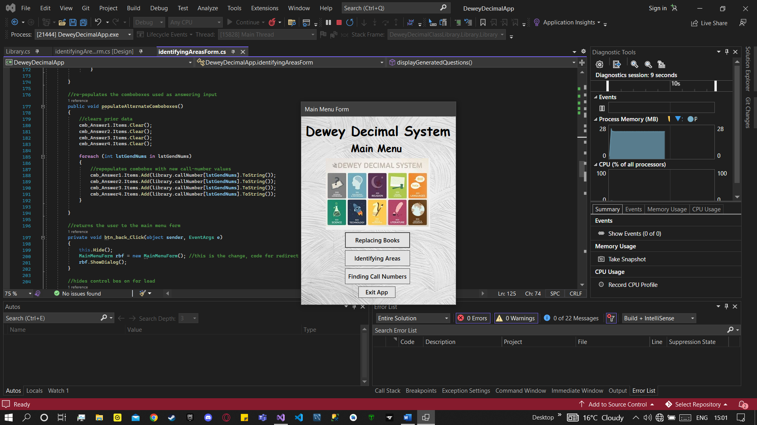

Step 14: To access ‘Identifying Areas’ function, click on the button.

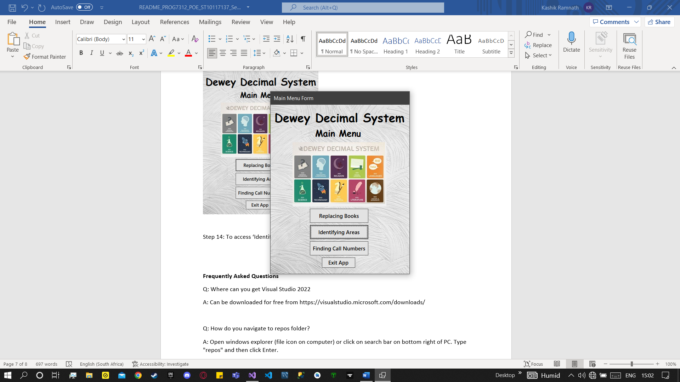

Step 15: click the question mark button for help on how to play the game

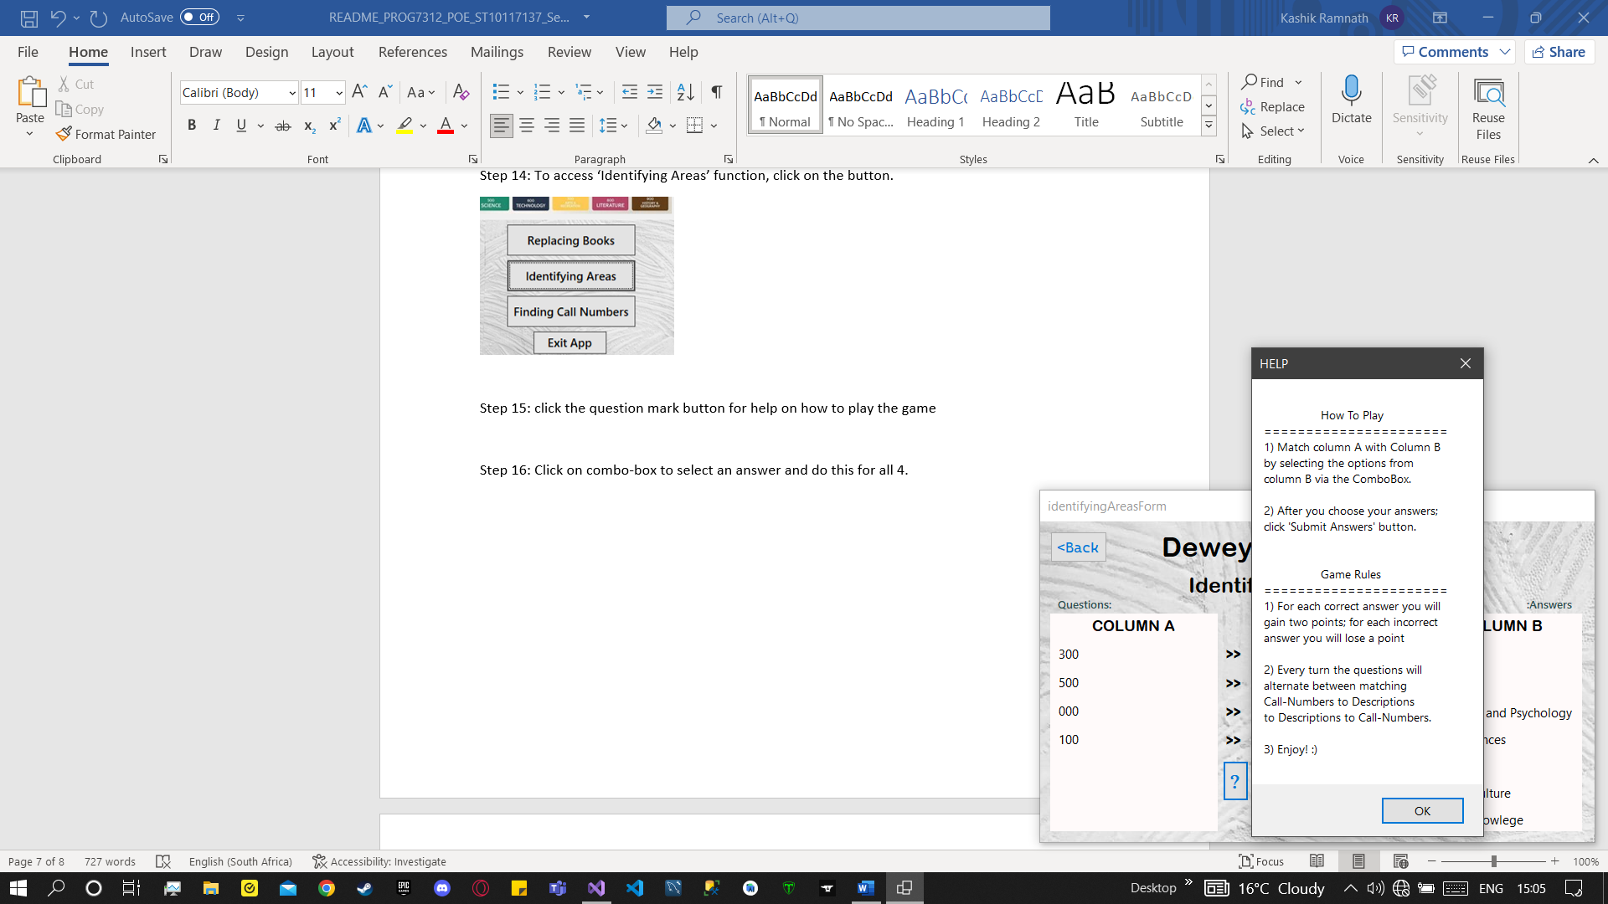

Step 16: Click on combo-box to select an answer and do this for all 4.

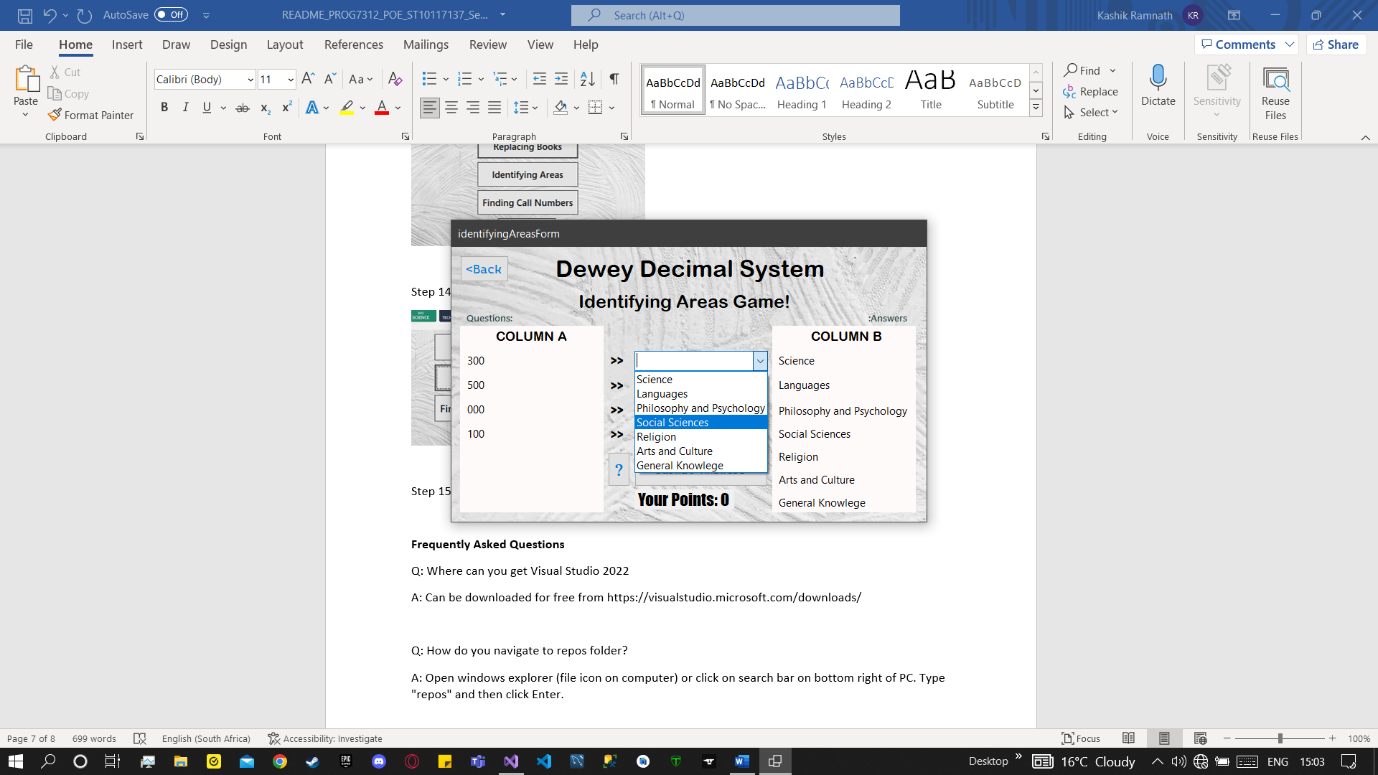

Step 16: click submit answers button to submit answers

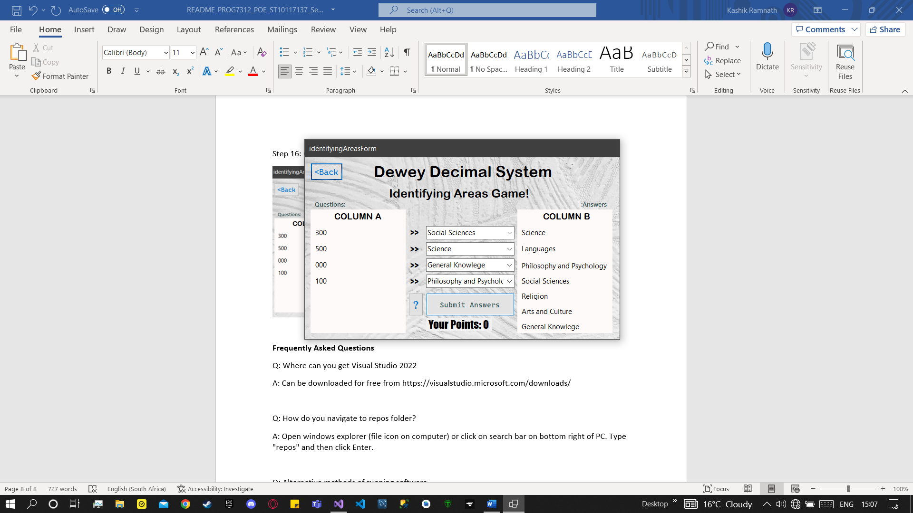

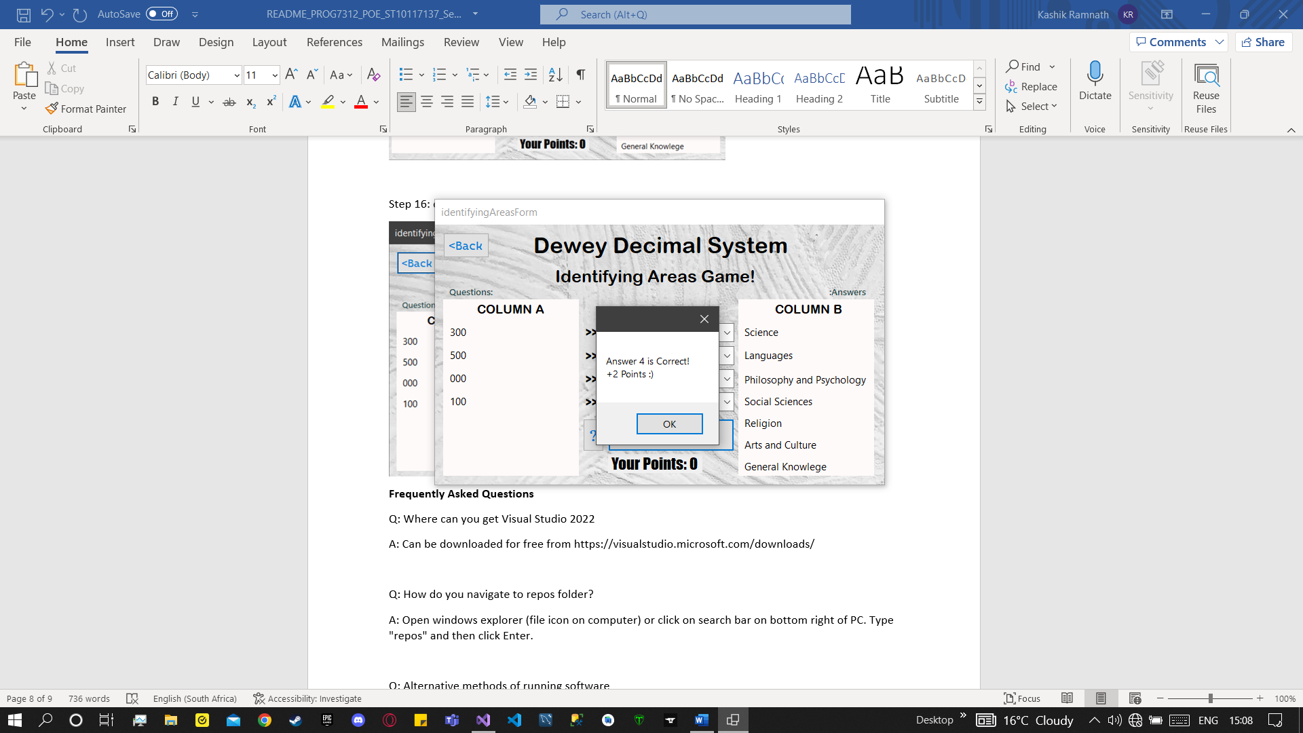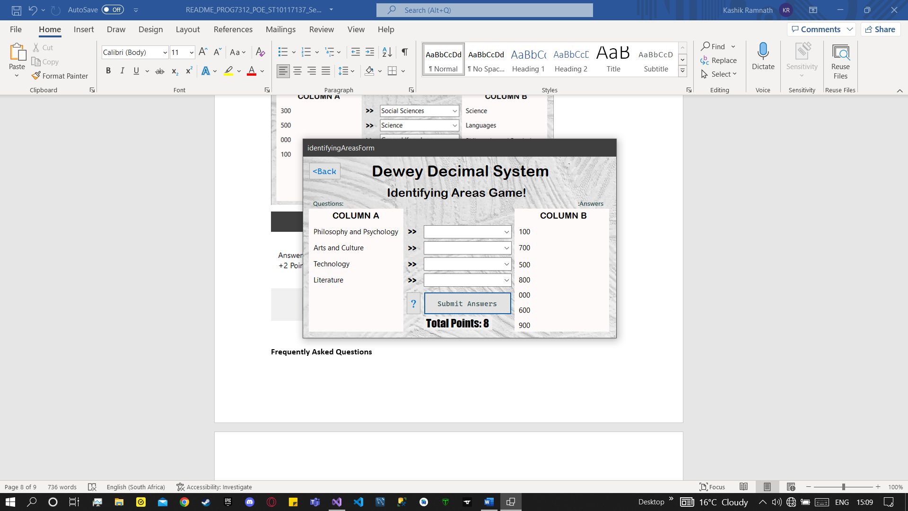

Step 17: Every turn column values are randomized and swapped, but functionality remains the same

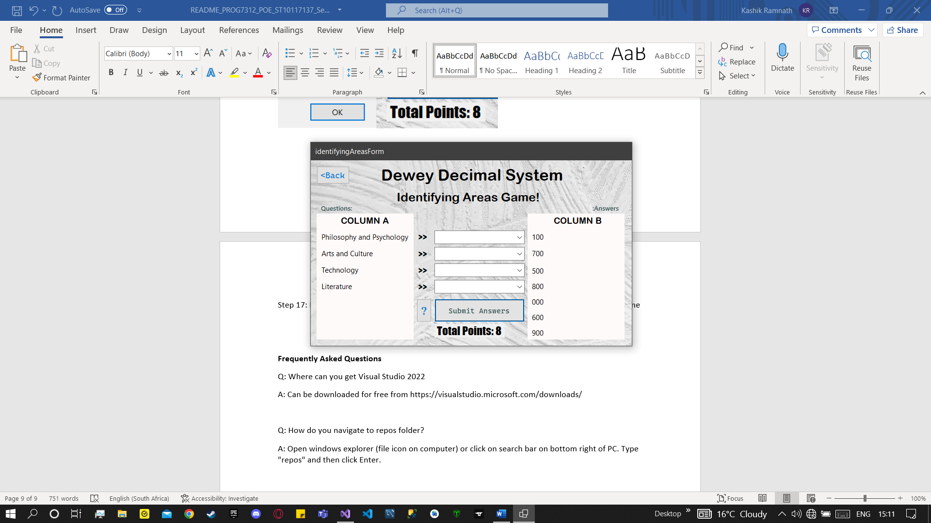

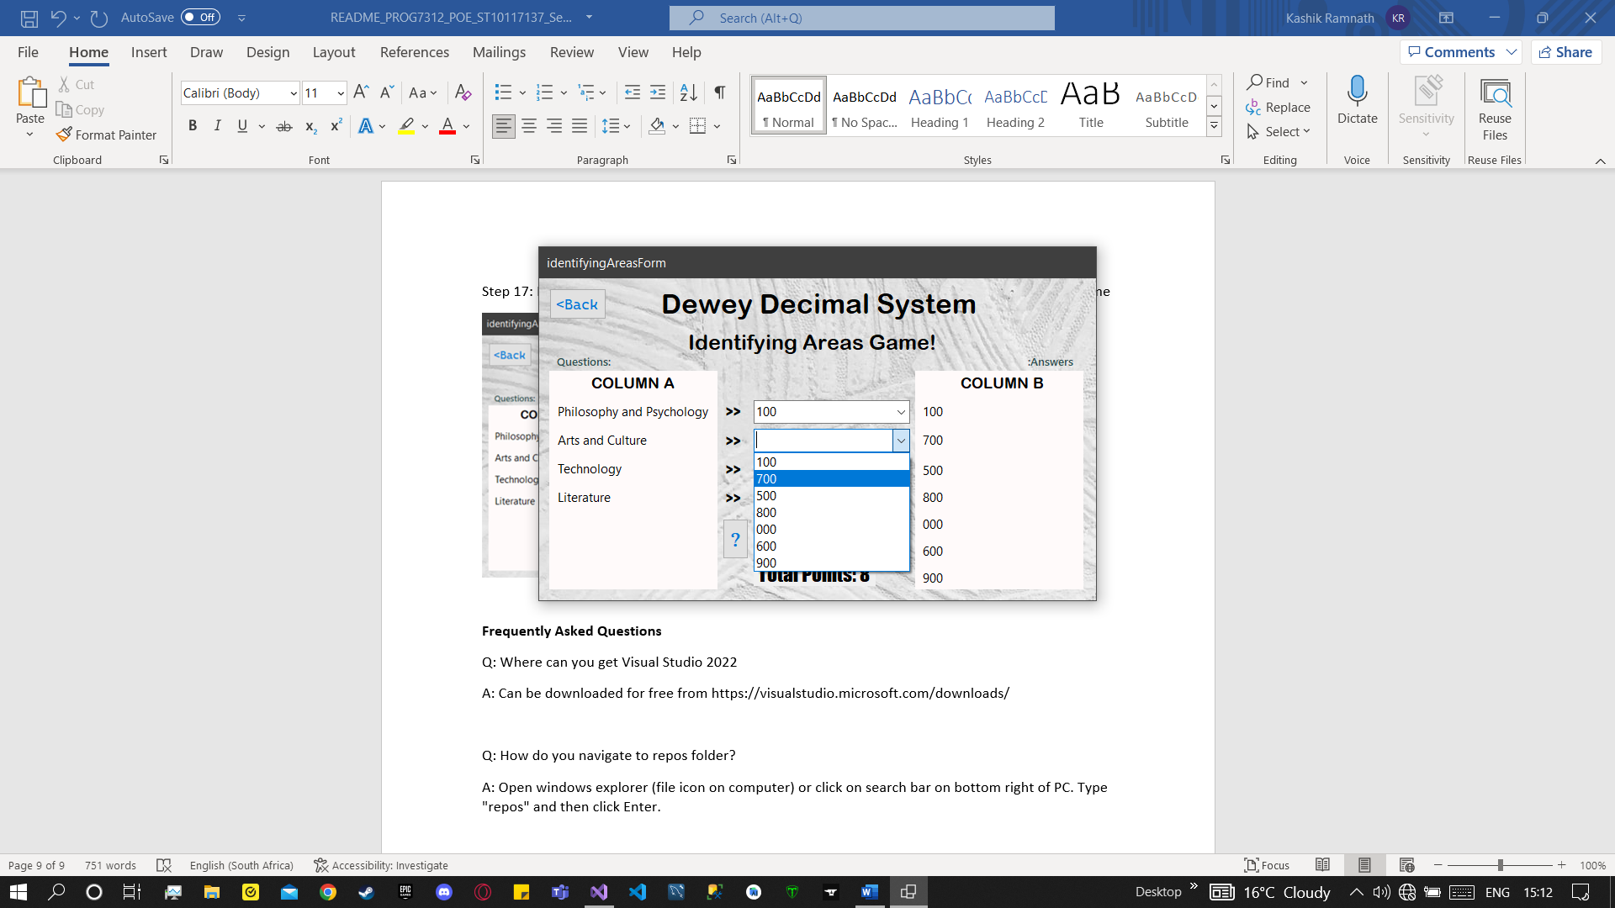

Step 18: Click ‘<back’ when ready to return to menu and ‘Exit App’ on menu screen to exit the app

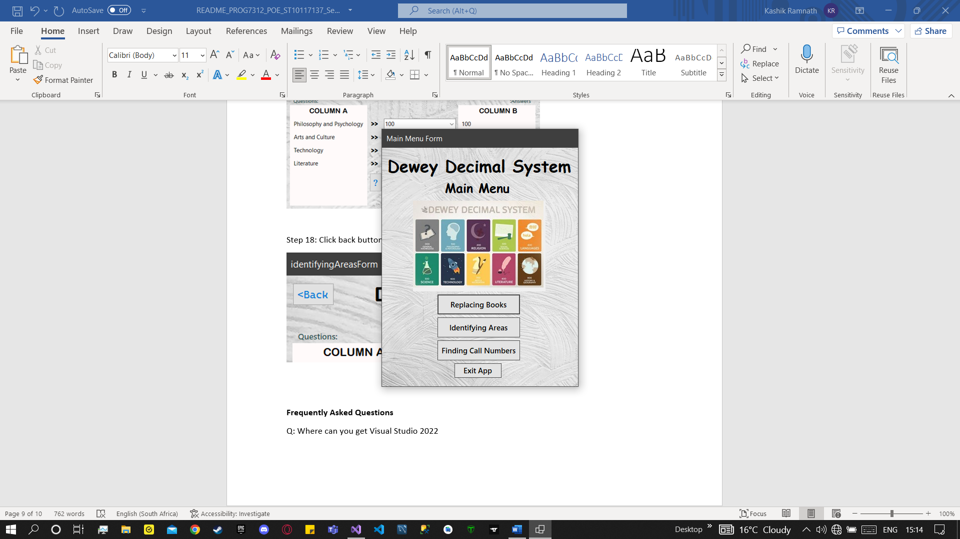

**Frequently Asked Questions**

Q: Where can you get Visual Studio 2022

A: Can be downloaded for free from https://visualstudio.microsoft.com/downloads/

Q: How do you navigate to repos folder?

A: Open windows explorer (file icon on computer) or click on search bar on bottom right of PC. Type "repos" and then click Enter.

Q: Alternative methods of running software

A: Alternative methods include:

1)Pressing f5 on keyboard.

2)Pressing the green play button on top mid of screen.

Q: File won’t open completely on Visual Studio 2022

A: Ensure file is extracted first. Right click on file and choose "Extract all..." option.

**Last Edited**

22/10/2022, 15:17pm

Kashik Ramnath, ST10117137